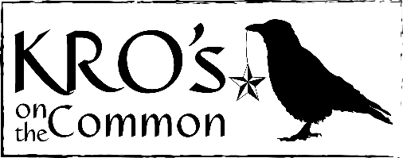
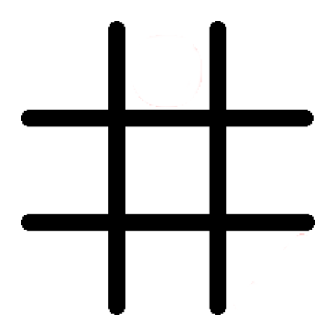

Children’s Breakfast Menu
2 Eggs with Bacon $5
Served with home fries
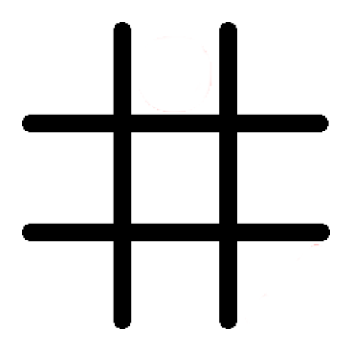
Homemade English Muffin $3
Peanut Butter & Jelly
1 Piece of French Toast $4
Butter & Syrup
Cheese Omelet $5
Served with home fries
Yogurt Bowl $5
Fresh Berries
Children’s Lunch Menu
Served with French Fries
Grilled Cheese $6
Cheeseburger $8
Ham OR Turkey & Cheese $7
Chicken Fingers $7

